TASK 3   
  
EMAIL ENCRYPTION USING RMAIL

1: Using Rmail to make an account linked to my gmail from windows 11 vm :

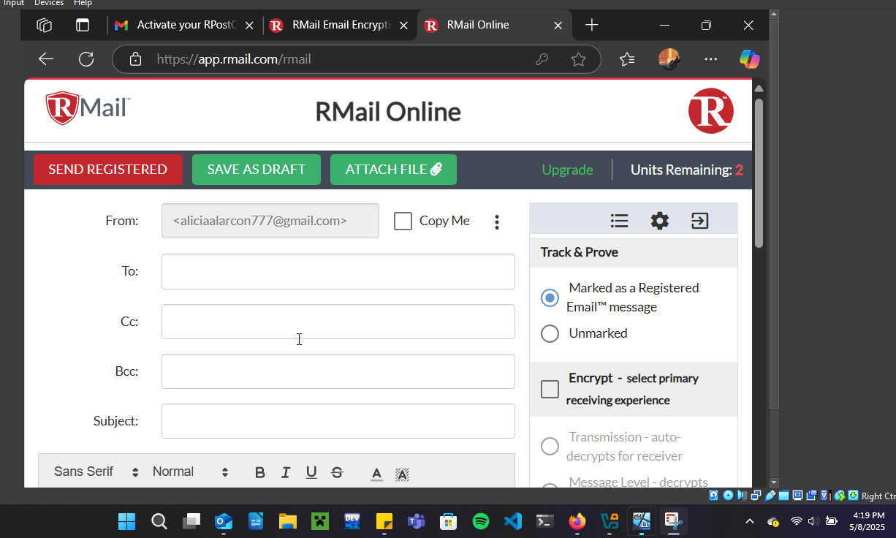

2: Sent a test email and got confirmation that it got send:

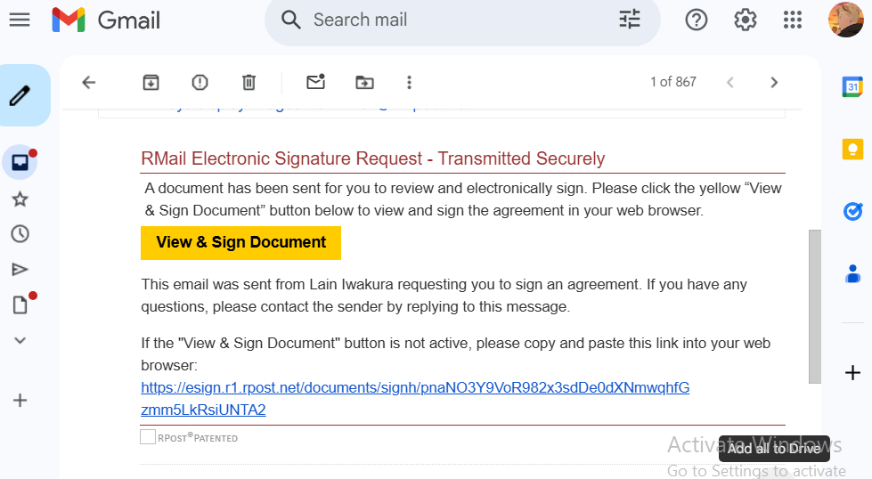

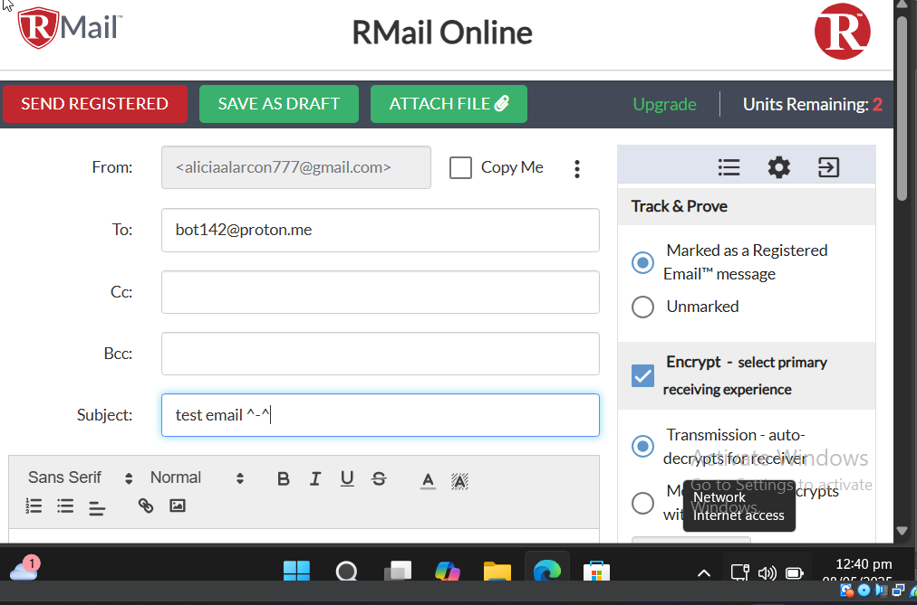

3: Viewing the email from the windows 2019 server vm:

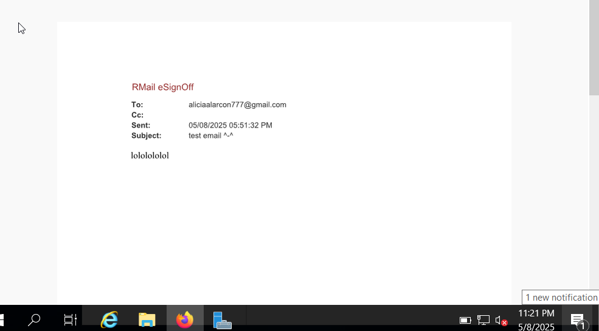

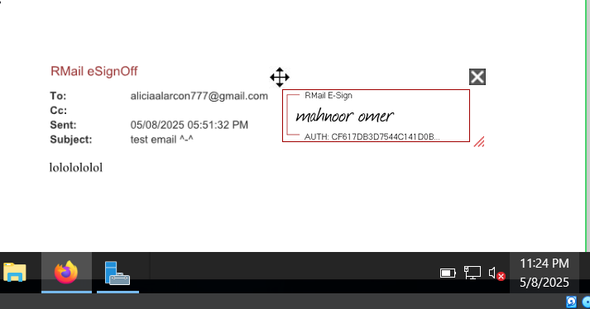4: Adding an electronic signature (from windows server 2019):

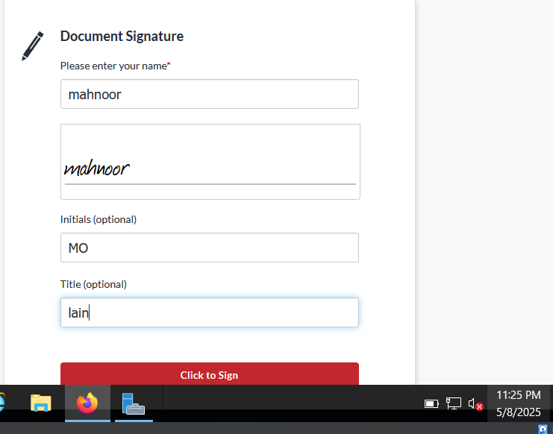

5: Confirmation for electronic signature:

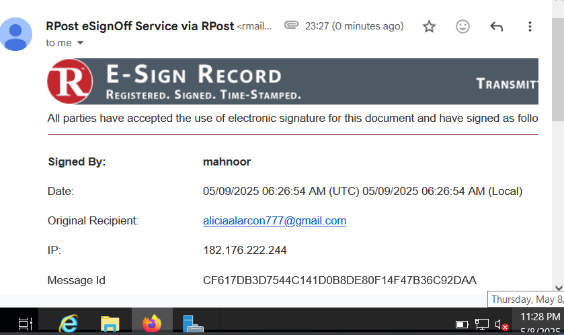

6: Proof of transfer email from Rmail with all the details (from the windows 11 server):

